Employer Quick Start Guide

Once you log into your NUworks account on the day of the fair, on the first screen, you will see "click here to start chatting with students in the Announcement section in the middle of the page. Please click the red “here” to get started.
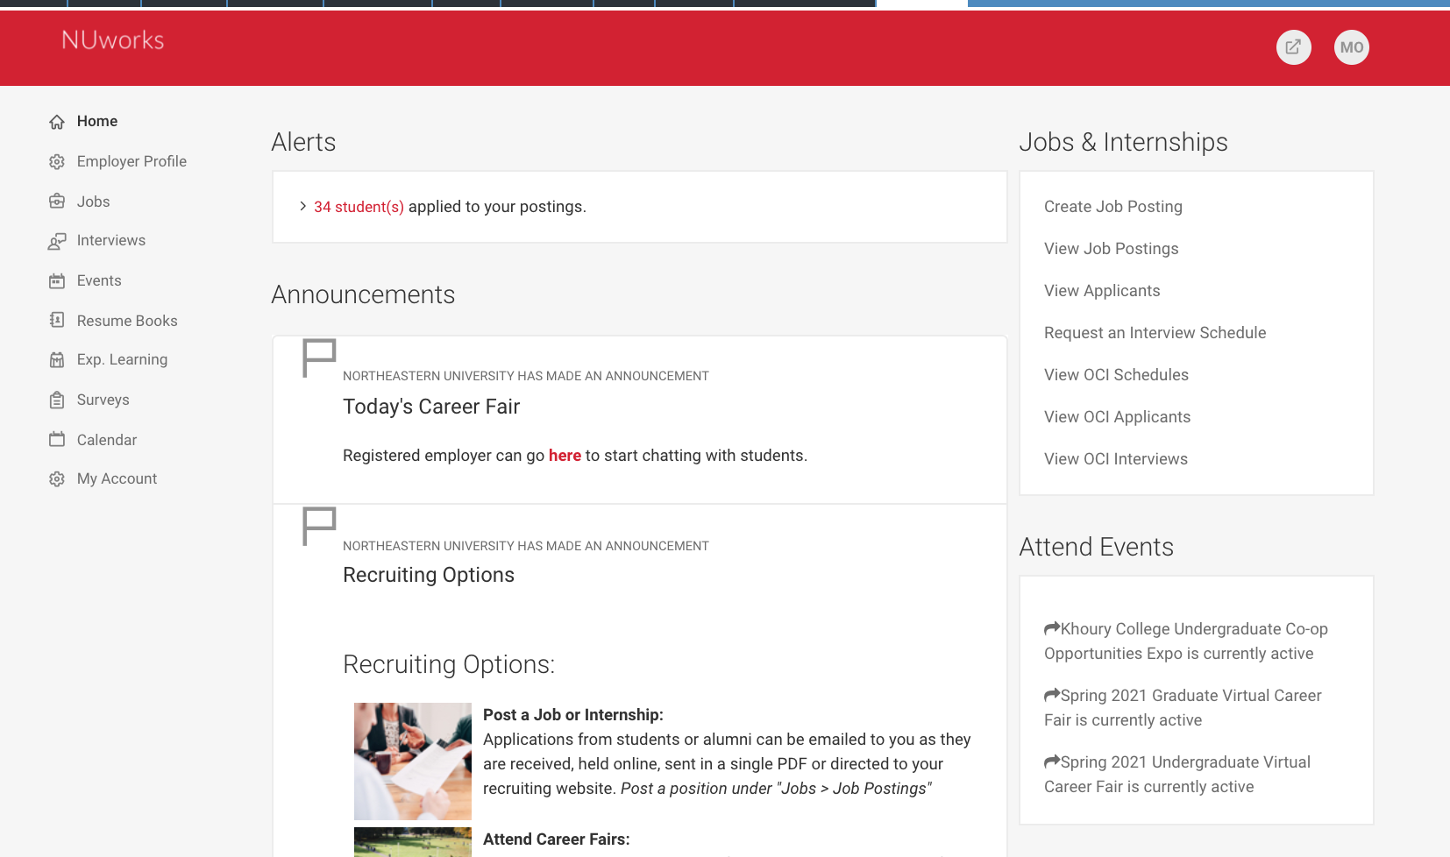

Next, click the “registered” button and navigate to all RSVP’d students.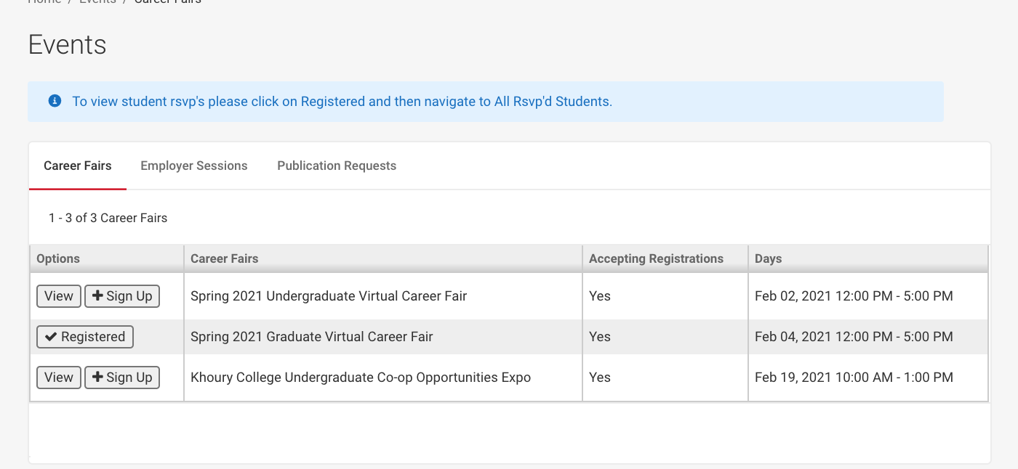

A button will appear where the red arrow indicates, which will say "start chatting with students."
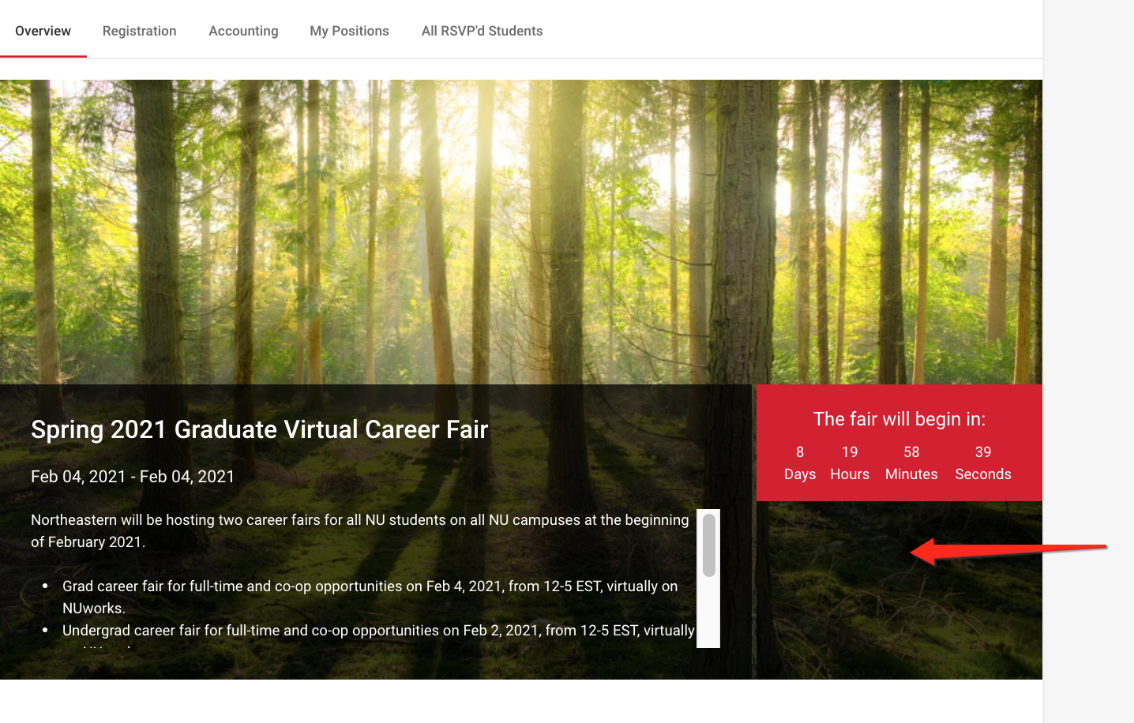

Below is a video link that will depict some other tips for navigating the fairs.

https://vimeo.com/446650071/5c4d65c59e

If you need help, please reach out to us at careers@northeastern.edu or call 617-373-2430.

