Honors Global Bank Account Funding for Global Co-ops

The Honors Global Bank Account is intended to support Honors students in their pursuit of global experiences, including global co-ops. Students have access to $6,000 in Global Bank Account funding throughout their time at Northeastern. This funding is intended to be used for at least two global experiences. Please see below for important information.

- Eligibility: Students who entered Northeastern as part of the Honors Program Fall 2017, 2018, 2019, and 2020 are eligible for the Global Bank Account (GBA). Students admitted prior to 2017, or who were admitted to Honors after their first semester at Northeastern (internal Honors admits), are eligible for the Presidential Global Scholarship (PGS). Please see visual below for further guidance:
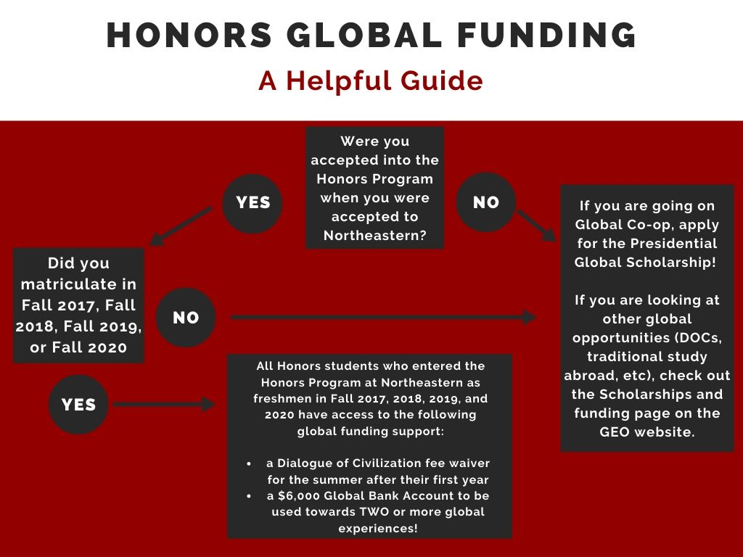
- Due to changes caused by COVID-19, there are currently two applications: one for on-site global co-ops and one for remote global co-ops.

On-Site Co-op:

Students may use their Honors Global Bank Account for an on-site global co-op, including home-country co-ops for international students.

- Students are expected to use the $6,000 for two or more global experiences.
  - If this requirement for two global experiences creates a financial hardship, and students feel that it is essential that they use the full $6000 for a single global experience (such as a 5-6 month global co-op), they may indicate that on their Global Bank Account withdrawal form.
- Can be used for approved travel expenses (full list also available on application):
  - Program fees
  - Flight (economy only)
  - Housing
  - Local transportation
  - Meals
  - Passport/visa fees
  - Required textbooks/materials
- Must provide documentation that travel is approved by the Global Safety and Security Assessment Committee (GSSAC)
  - Link to travel petitions are included on our website along with the Global Bank Account Withdrawal Request form.
- Must provide documentation of employment with global co-op

Remote Global Co-op:

In response to COVID 19 and the effects on co-op experiences, the University Honors Program has announced its decision to also enable eligible Honors students to use a portion of their Honors Global Bank Account to support remote, non-US global co-ops.

- Student must be participiating in a remote GLOBAL co-op. Remote U.S. Co-ops are not eligible
- Funds can only be used for:
  - Agency fees
  - Required Technology Upgrades.
  - Students not living at home can request funds be used toward living expenses
    - ***These requests are considered on a case by case basis and funding is not guaranteed
- Must provide documentation of approved remote co-op
- Must also provide documentation of expenses: this can be a budget, proof of technology fees, proof of rent, etc.
- If a remote opportunity becomes onsite requiring global travel and expenses, the student may contact the Honors Program to ask for additional funding. However, the total amount withdrawn cannot exceed $5000. For example, if a student initial took out $2,000, they could request up to an additional $3,000, provided they have expenses equaling $3,000), assuming they have sufficient funds left in their Bank Account to cover these additional expenses.

Application Process:

- Students must apply PRIOR to their global experience
- Access On-site application: https://provostweb.wufoo.com/forms/zpcih2t1dy8rj2/
- Access Remote application at https://provostweb.wufoo.com/forms/z1hwehm500deitq/
- Application Timeline:
  - Applications accepted on a rolling basis.
  - Response typically within 2 weeks.
  - Honors will send students an e-mail upon processing and will inform them if there are any changes in the amount, or if the request cannot be processed (if applicable)
- Approved Awards:
  - Funds will not be officially added to students’ financial aid package until close to the start of their global experience/academic term. Financial aid package information can be viewed via the My Financial Aid Status section of the myNortheastern portal under Services and Links.
  - Once funds are awarded, the money will officially disburse after the experience/semester has officially begun.
  - If students need access to funds prior to the start of the global experience, please reach out to Barbie Papalios to discuss options.

Questions?

E-mail Barbie Papalios at b.papalios@northeastern.edu

